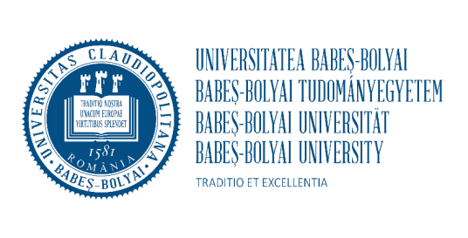
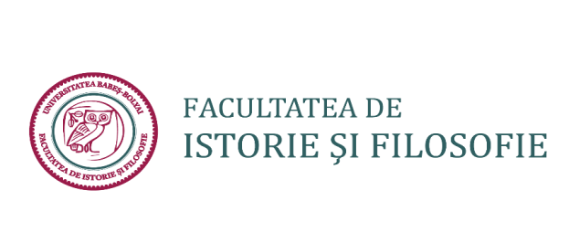

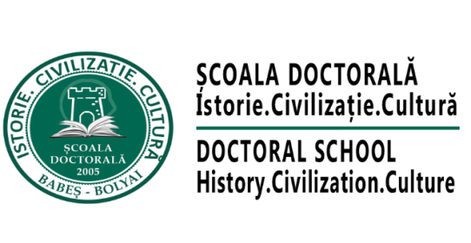

CALL FOR PAPERS
INTERNATIONAL CONFERENCE OF THE DOCTORAL SCHOOL IN HISTORY
Twentyfirst Edition

THE DEMISE OF RULERS, POLITICAL UPHEAVALS AND THE PLIGHT OF THE PEOPLE
FROM EVENT-CENTRED SCHOLARSHIP TO SOCIAL HISTORY
(TWENTIETH AND TWENTY-FIRST CENTURIES)

12-14 November 2026
Cluj-Napoca
In 1526 the Hungarian Army was defeated by the Ottomans on the battlefield at Mohács. The event was perceived as a tragedy by its contemporaries, who dwelt on its dire consequences, as the king was killed along with a significant number of noblemen and bishops. Moreover, during the following decades, the kingdom was divided: while Royal Hungary came under Habsburg rule, central Hungary was administered by the Ottoman Empire, while Transylvania became an autonomous Principality, under Ottoman authority. While bemoaning this tragedy, these accounts hardly ever mention the effects of these events on a broader social segment. It is thus left to historians to explore the consequences of these upheavals for ordinary people. Making occurrences in medieval Hungary a centre point for further discussion of similar events, from any time period or region, for example from the death of the Dacian king Decebalus in 106, to the death of Nicolae Ceauşescu in 1989, the conference organisers would like to invite PhD students to reflect on the effects of the demise of rulers, political upheavals and their consequences in social and cultural terms, and ultimately engage with history from below. By addressing topics such as archaeologies of power (expressed in architecture, funerary customs, status symbols, art, writing), social networks and associations in the modern era, confessionalization and mechanisms of social control, the status of the peasantry in the early modern period, urban life and social diversification, the dissolution of traditional communities under communism, to give just a few random examples, participants are invited to explore understandings of and reactions to major events in diverse contexts.
These presentations of new and innovative research will provide opportunities for a broader discussion of changes within social history in the twentieth and twenty-first centuries, the emergence and development of various schools of thought, research methods and approaches, surfacing in the wake of the New Social History and its aftermath. While some scholars have predicted “the death of social history,” others have advocated “post-social history,” and the emergence of “antisocial history.” Consequently, attention has turned to the devolution of the social as a relevant and viable category and history without groups has been mentioned. Starting from the premise that the social, as a theoretically-defined and empirically-researched concept, will remain a concern for historians and social scientists, its value as a heuristic tool will be explored, despite the fact that dissatisfaction with ways of discussing the social, dominant in the 1960s and 1970s has occurred. This more general trend has led to the re-conceptualization of the social, as critiques of this category, initiated in the 1980s, extended to critiques of the cultural. Meanwhile, in the 1990s, east-central Europe experienced a “social turn” of its own, contributing, as Constantin Iordachi has pointed out, to a cross-fertilization of east-central European and western historiographies, which can fuel the resuscitation of social history.
Focusing on their own topics of research within broad geographical and chronological limits, we invite PhD students to consider the changes triggered by political upheavals on a broader social spectrum, the diversity of sources available for this type of research, including aural, visual and material ones and the methods that could be deployed, often informed by the dialogue with cultural history.
The conference will begin with a roundtable dedicated to the Battle of Mohács and its aftermath. Participants include Mária Lupescu Makó (Babeş-Bolyai University of Cluj), Robert Kurelic (University of Pula), Attila Bárány (University of Debrecen), Tamás Pálosfalvi (Institute of History, Budapest), Marian Coman (University of Bucharest), Carmen Florea (Babeș-Bolyai University of Cluj) and Radu Mârza (Babeș-Bolyai University of Cluj) .
We are happy to announce that plenary lectures will be given by:
Sophie Krausz (Université Paris 1 Panthéon-Sorbonne, Academia Europea), who will address the topic of archaeologies of power (title to be announced)
Marian Coman (University of Bucharest), Communities of Wallachia (fifteenth-sixteenth centuries)
Andrea Fehér (Babeş-Bolyai University of Cluj), From the Social to the Intimate? Wet Nursing and the Changing Boundaries of Historical Inquiry
Virgiliu Ţârău (Babeş-Bolyai University of Cluj), Social History and the Historiography of Communism after the Cold War
In an attempt to encourage academic dialogue, the conference will take place on site in Cluj and will be hosted by the Faculty of History and Philosophy. As has become the custom, some of the papers presented at the conference will be selected for publication, in English, in the Supplement of the periodical Studia Universitatis Babeş-Bolyai. Historia (CEEOL, ERIH+, EBSCO) and, in Romanian, in the Annual of the Doctoral School. History. Civilization, Culture (Anuarul Școlii Doctorale. Istorie. Civilizație. Cultură).

Practical details:

- The title of the presentation, together with the institutional affiliation, the name of the supervisor and an abstract of maximum 300 words in Romanian and English, for students from Romania, and in English for international students needs to be sent by 21 October 2026 to maria_silvia.craciun@yahoo.com
- Participants will have 20 minutes for their presentations which will be followed by 10 minutes of discussion
- The organisers will reply to all applications by November 1st 2026
- Participants will receive the conference program by November 10th 2026
- Accomodation and meals are the responsibility of the organisers
- The conference fee is 500 Ron for Romanian participants and 100 euro for international participants. We will send payment details once you’ve confirmed your interest in participating.

We look forward to seeing you in Cluj!
Maria Crăciun, Gelu Florea and Gheorghe Negustor

